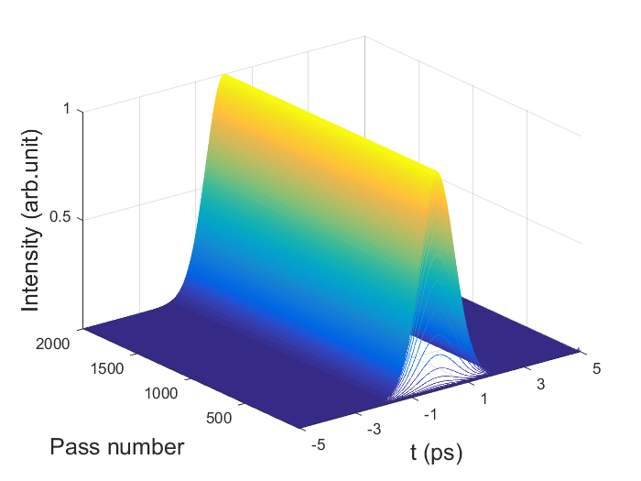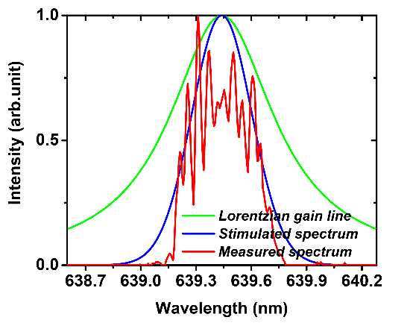

**(b)**

**(a)**

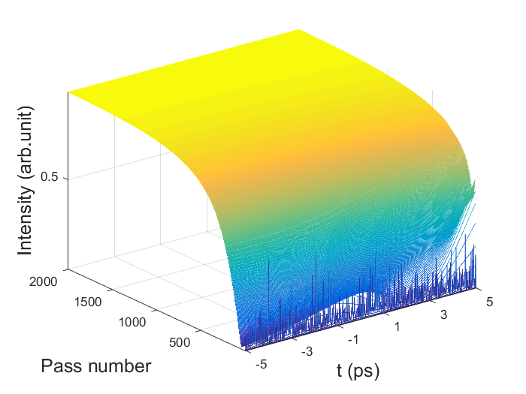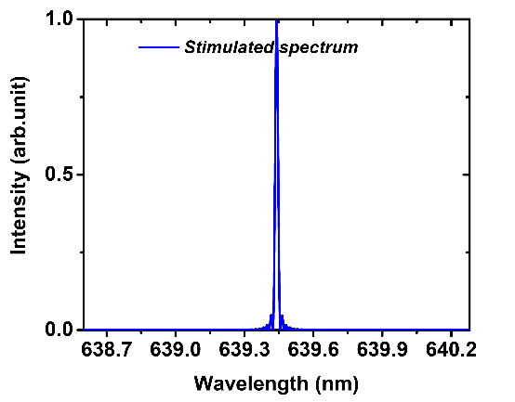

**(d)**

**(c)**

**图 6. 没有增益谱线频移的情况下脉冲演化过程以及最终光谱. (a) (b)有光强调制; (c) (d)无光强调制.**

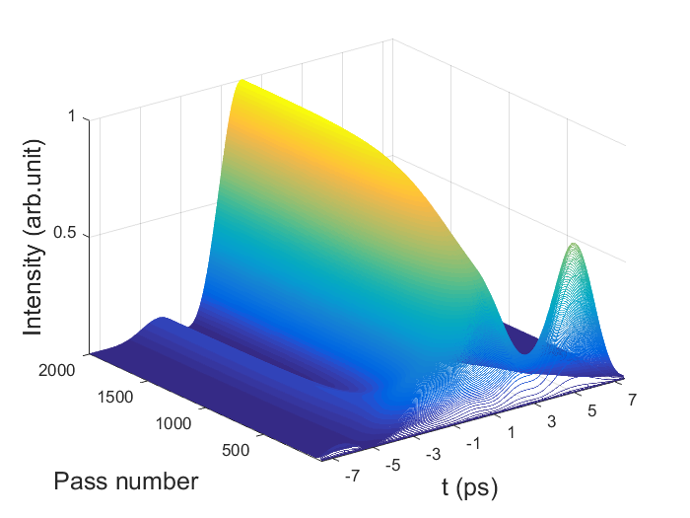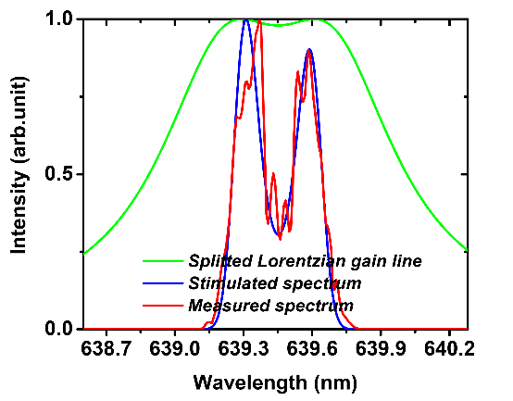

**(a)**

**(b)**

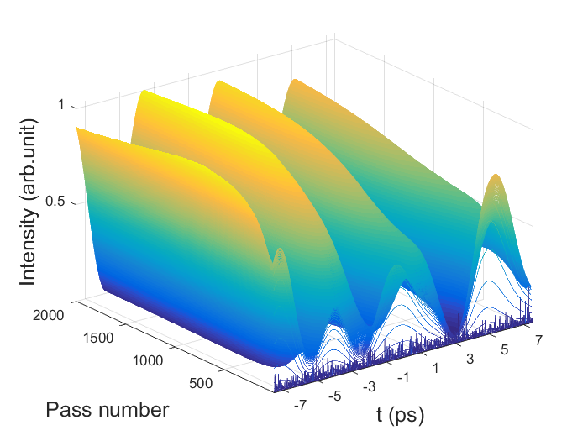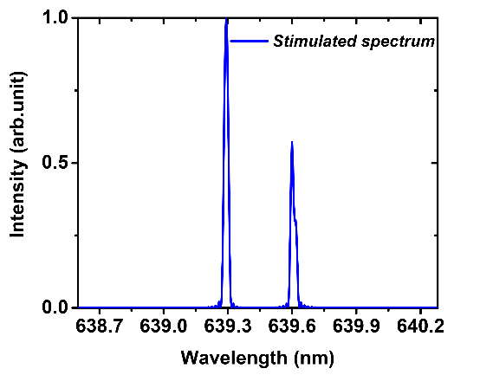

**(d)**

**(c)**

**图7. 有增益谱线频移的情况下脉冲演化过程以及最终光谱. (a) (b)有光强调制; (c) (d)无光强调制.**

本章提出的自启动Kerr棱镜锁模模型包含了激光增益介质以及Kerr光束压缩效应。其中激光增益介质可以被认为是具有一定频率滤波线型的光信号放大器，而Kerr光束压缩效应可以由光强度调制模型来模拟。对于光信号放大模型，应当把光强度饱和效应考虑进去，因此增益系数*g*可以写为

,(1)

其中 *g*ss 是小信号增益系数，*P* 是信号功率，*P*sat 是饱和功率。对于Pr3+:YLF固体增益介质来说，其增益谱线展宽属于均匀展宽，满足洛伦兹线型 [2016, Li Qing-Song]. 所以其增益系数可以表达为

,(2)

其中 *ν*0 为频率中心，*Δν* 为激光增益线型的半高全宽 (FWHM)。对于640 nm跃迁谱线 3P0→3F2，波长的半高全宽*Δλ* 为0.69 nm，对应的线宽*Δν*为506.2 GHz。由于Kerr自聚焦效应在时间域和空间域对光脉冲具有压缩作用，这就相当于对腔内激光光强进行了被动调制。光强调制的模型可以简单地表示为时域的高斯线型，公式如下，

,(3)

其中 *t*0 参考时间，一般设为0，*Δt* 为调制信号的半高全宽。这里激光增益介质同时起到了光放大和Kerr介质的作用。激光通过晶体后在空气中传播，传播过程中没有色散以及非线性效应的作用，其传播过程可以通过简单的线性微分方程来描述，

,(4)

其中 *L* 为腔内往返损耗。该方程可以通过有限元积分的方法来进行数值求解。激光在经历了一次往返后，被重新注入到增益介质中，并进行下一次往返。这个过程周而复始，直到建立平衡。

The simulation results that coincides with the FWHM of the measured spectrum depicted in Figure 6 (b), which was 0.39 nm, is depicted in Figure 6(a) and (b). In this simulation, the FWHM of the modulation signal *Δt* was tuned to 3.5 ps so that the FWHM of the calculated spectrum was also 0.39 nm. As is shown in Figure 6(a), a stable optical pulse was obtained with a pulse width of 1.5 ps, leading to a time-bandwidth product of 0.427, meaning a transform limited result. As a comparison, simulations with no intensity modulation was also carried out, the response in time domain and the simulated wavelength are illustrated in Figure 6(c) and (d), respectively. As can be seen, the result in the time domain becomes a direct current signal, and the FWHM of the simulated wavelength was shortened, corresponding to a continuous-wave operation state.

It is interesting to note that, in our experiments, meanwhile the laser was mode-locked, laser spectrums with a relatively big dip in the center shown as the red line in Figure 7(b) were sometimes captured. The possible reason for the dip in the laser spectrum is the frequency shift caused by gain-line splitting [93, Zhijiang Wang]. By introducing a frequency shift of the Stark splitting *Δνs* from the unperturbed frequency induced by the intra-cavity laser field, Eq. (2) can be written as

,(5)

By substituting Eq. (5) into the system instead of Eq. (2) and adjusting the frequency shift *Δνs* to 176 GHz (corresponding to a wavelength of 0.16 nm)and modulation duration in Eq. (3) to 45 ps, we can obtain a simulated spectrum almost identical to the registered one shown as the red line in Figure 7(b), with a FWHM of 0.39 nm. As shown in Figure 7(a), the FWHM of the corresponding optical pulse was 2.4 ps, resulting in a time-bandwidth product of 0.936. It should be noted that, to get the simulation results, the duration of intensity modulation model raised almost 13 times compared with the case without frequency shift resulted from gain line splitting, which reveals the fact that the stark shift has the effect of modulating intensity, or in another word, compressing optical pulses. This conclusion is consistent with the experimental results reported by J. J. Sanchez-Mondragon in 1986 [86, J. J. Sanchez-Mondragon].

The frequency shift of the gain line stark splitting was once considered as the cause of self-start mode locking [92, Zhijiang Wang]. As shown in the green line in Figure 7(b), the amount of frequency shift in our case (*Δνs* to 176 GHz, *Δν* of 506 GHz) already meets the requirements for the rough self-mode-locking criterion 12*Δνs*2 >*Δν*2 of solid-state lasers. For verification of the origin of self-start mode locking, we removed the intensity modulator and made the same simulation, the results are shown in Figure 7(c) and (d). As can be seen, frequency shift caused by gain line splitting would induce fluctuations of transient laser power in the time domain, but it alone cannot give rise to stable ultra-short pulses with a period of the cavity round-trip time without the help of intensity modulation, which might be caused by Kerr-lensing effect.

[2016, Li Qing-Song]. L. Q. Song, Z. L. Xi, Z.X. He , D.Yuan, Y.Y. Ji, and J.G. Yong, “The effect of the depth of single longitudinal mode modulation in Q-switching pre-Pr3+:YLF laser”, Optics Communications 372(2016)250–254

[92, Zhijiang Wang]. Y. X. Bai, S.S. Chen, Z.J. Wang , and G.Q. Zhang. Novel self-mode-locking mechanism in narrow-band lasers. American Institute of Physics, 63, (1993)

[86, J. J. Sanchez-Mondragon]. J. J. Sanchez-Mondragon and G. E. Torres-Cisneros, Pulse compression caused by a spectral hole in an inhomogeneously broadened line of an amplifier. J. Opt. Sot. Am. B 4, 64 (1987).